Physics 30 Lesson 28

Quantization of Energy & Light

As we saw in the previous lesson, Rutherford’s model of the atom had some serious difficulties. But before we can proceed with a discussion of Bohr’s model of the atom (Lesson 31) we must look at one of several major revolutionary ideas that shook the world of physics in the early part of the twentieth century, namely **quantum theory**. The revolution of quantum theory required almost three decades to unfold, and many scientists contributed to its development. It began in 1900 with Planck's quantum hypothesis and culminated in the mid-1920s with the theory of quantum mechanics of Schrödinger and Heisenberg which has been so effective in describing the structure of matter.

Refer to Pearson pages 702 to 710 for a discussion about the quantum nature of matter and light.

# Blackbody radiation

One of the observations that was unexplained at the end of the nineteenth century was the spectrum of light emitted by hot objects. At normal temperatures (300 K), we are not aware of this electromagnetic radiation because of its low inten­sity and long wavelength. At higher temperatures (~500–600 K), there is sufficient infrared radiation that we can feel heat if we are close to the object. At still higher temperatures (~1000 K) objects visibly glow, such as a red-hot electric stove burner or the heating element in a toaster. At temperatures above 2000 K objects glow with a yellow or whitish color, such as white-hot iron and the filament of a light bulb. As the temperature increases, the electromagnetic radiation emitted by bodies is strongest at higher and higher frequencies (smaller wavelengths).

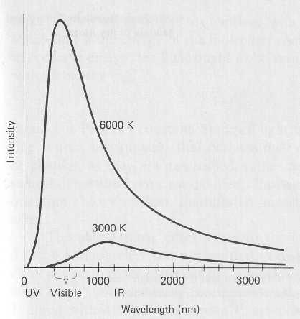

The curves of light intensity Vs wavelength for different temperatures are called **blackbody radiation curves**. The term **blackbody**, introduced by the German physicist Gustav Kirchhoff in 1862, refers to an object that completely and perfectly absorbs any light energy that falls on it and then perfectly reradiates the energy as light energy. The energy it reradiates can be depicted as a **blackbody curve**, which depends on temperature only. In the figure to the right, note that the 6000 K curve, corresponding to the temperature of the Sun, peaks in the visible part of the spectrum. For lower temperatures the total radiation drops considerably and the peak occurs at longer wavelengths. Refer to Pearson pages 704 and 705 to see other blackbody curves.

A major problem facing scientists in the 1890’s was to explain blackbody radiation. Maxwell's electromagnetic theory (Lesson 24) had predicted that oscillating electric charges produce electromagnetic waves. A thermodynamic approach reasoned that hot objects like the filament in a light bulb emit light as a result of the vibrating atoms/charges in the filament. Since heat is manifest as a faster, more violent vibration of atoms in the object, the frequency of the radiation emitted by a hot object should increase as the temperature increases. But an application of these ideas did not work. In 1896 Wilhelm Wien derived a theory that fit the data quite well for shorter wavelengths, but did not work for longer wavelengths. Applying other thermodynamic ideas, Lord Rayleigh and Sir James Jeans (1900) derived a different law which agreed with results at long wavelengths, but failed miserably at short wavelengths. (See Pearson page 705.) It became clear that neither the Wien nor the Rayleigh-Jeans formulations were in accord with experiment.

Not only did classical physics fail to explain the relationship between temperature and the blackbody curve, it also made a completely absurd prediction: A hot object would emit its energy most effectively at short wavelengths. This prediction leads to a rather bazaar conclusion. If you heat an object it will emit a small amount of infrared energy, a little more red light energy, more blue, a lot more ultraviolet, a tremendous amount of X-ray energy, and so on. In short, heating an object would result in an infinite amount of gamma radiation being produced!! This prediction was called the **ultraviolet catastrophe** and it was obviously false.

# Planck’s quantum theory of matter

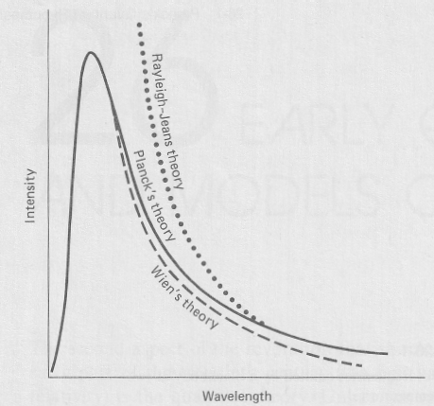The breakthrough came in late 1900 when Max Planck (1858–1947) proposed an **empirical** formula that nicely fit the data. (An empirical formula is an equation that fits experimental (i.e. empirical) results, but does not explain the results.) Planck then sought a theoretical basis for the formula and within two months found that he could obtain the formula by making a new and radical assumption: that the **energy** distributed among the molecular oscillators **is not continuous but instead consists of a finite number of very small discrete amounts**, each related to the frequency of oscillation by



where h is a constant, now called Planck's constant, that has an accepted value today of

 (in this course we use )

Planck called each discrete bundle a **quantum** (“quantum” means “fixed amount” and the plural is **quanta**). The smallest amount of energy possible (hf) is called the **quantum of energy**. His assumption suggested that the energy of any molecular vibration can only be some whole number multiple of hf (1hf, or 2hf, or 3hf, and so on), and there cannot be vibra­tions whose energy lies between these values.



That is, energy is not a continuous quantity as had been believed for centuries. Rather energy is quan­tized – it exists only in discrete amounts. This is often called Planck's **quantum hypothesis**. It appears that Planck considered it more as a mathematical device to get the “right answer” rather than as a discovery comparable to those of Newton. For many years Planck himself resisted the assumptions he had made – they were just too weird – and he continued to seek a classical explanation. The recognition that this was an important and radical innovation did not come until later when others, partic­ularly Einstein, entered the field. The concept of the quantum marks the end of classical physics and the birth of quantum physics.

In 1905, a young and not-yet-famous Albert Einstein made a very bold suggestion. While Planck thought that quantization applied only to how matter could absorb or emit energy, Einstein suggested that this idea implied that light itself was quantized. Planck's formula,

 or 

can therefore be used to calculate the energy of one or more quanta or **photons** of light. (In 1926, the chemist Gilbert Lewis introduced the term **photon** to describe a quantum of light.)

Beginning with E = nhf, show that .

All light has a speed c and, using the universal wave equation , we can substitute .



What is the energy of an infra-red photon with a frequency of 3.45 x 1014 Hz?



The wavelength of a ruby laser is 650 nm. If the power of the laser is 1.5 W, how many photons are coming out of the laser every second?

First, calculate the energy of the laser light emitted in one second.





Second, calculate the number of photons.

# Quantization

The classical idea about energy was that it could come in any size or amount that one desired. The idea that energy came in discreet bundles was foreign to the classical notion of the universe. However, the idea of some things being **quantized** was not entirely foreign to classical physics. For example, electric charge is quantized – any charge on an object is the result of an excess or deficit of a **whole number** of electrons. There is no such thing as an object having ½ an electron charge. The only charges permitted are 1, 2, 3, … n electrons of charge.



It is important to note that the idea of quantization of charge does not become important until we start looking at very small objects like electrons, protons, ions, atoms, and the like. For objects with large charges involving an excess or deficit of billions and trillions of electrons, the effect and limitation of quantization (i.e. the charge of one or two electrons) is not noticeable.

The same is true for the quantization of energy. For relatively large energy values quantization is not noticeable or necessary to account for. But for small values, like those of individual photons and quanta, the law of quantization becomes very important.

When Planck found that the quantization of energy was required to explain blackbody radiation, physicists started to understand that the physics of the atomic size world (electrons, protons, nuclei, atoms, light) had to be described in a very different way from the physics of large objects and energies (everyday objects). This is the basic difference between quantum physics and classical physics. But old ideas die hard. The majority of physicists at the time, especially those were older, would not accept the quantum idea. As Planck said, “A new scientific truth does not triumph by convincing its opponents and making them see the light, but rather because its opponents eventually die and a new generation grows up that is familiar with it.”

# A different unit of energy – the electron volt (eV)

Recall from Lesson 16 that when an electron gains energy through a 1.0 Volt potential difference its energy is calculated as



Thus, if we are using Coulombs and Volts our unit for energy is Joules. However, in the quantum world the energies are quite small. Therefore a different unit of energy is often used called an **eV** or **electron volt**. In this unit the charge of an electron is **1 e**. An electron volt is the amount of energy that one electron gains when it falls through a potential difference of one Volt.



To convert between electron volts and Joules: **1 eV = 1.60 x 10-19 J**

It should also be noted that Planck’s constant can have one of two values depending on whether we are dealing with Joules or electron volts.

If the energy is in Joules then h = 6.63 x 10-34 J·s

If we are working with electron volts then h = 4.14 x 10-15 eV·s.

An electron is accelerated through a potential difference of 2000 V in a cathode ray tube. What is the energy of the electron in eV and in Joules?





A quantum of electromagnetic radiation has an energy of 5.00 eV. What is the wavelength of the radiation?



Note that since we are using eV as our energy unit, Planck’s constant is 4.14 x 10-15 eV·s

# Practice problems

1. What is the energy of a quantum of radiation which has a frequency of 3.45 x 1014 Hz? (2.29 x 10-19 J)

2. A photon has an energy of 5.0 eV. What is its wavelength? (2.5 x 10-7 m)

# Hand-in assignment

1. What is the energy (in Joules and eV) of a radio wave photon with a frequency of 100.7 MHz? (6.67 x 10-26 J, 4.17 x 10-7 eV )

2. What is the energy of a photon of blue light which has a wavelength of 450 nm? (4.42 x 10-19 J)

3. What is the frequency of a quantum of EMR whose energy is 1.0 MeV? What type of EMR is this? (2.4 x 1020 Hz)

4. A red neon laser has a wavelength of 632.8 nm. If the power of the laser is 1.50 mW, how many photons are being emitted per second? (4.77 x 1015)

5. A regular light bulb is about 5.0 % efficient in producing light energy from electrical energy. How many photons are released per second by a 50 watt light bulb if the average wavelength emitted is 500 nm? (6.3 x 1018)

6. When prints are developed in a darkroom, a red light bulb may be used for certain types of film. Why does the red light not affect the photographic film?

7. What can you say about the relative temperatures of reddish, bluish, and whitish-yellow stars?

8. If all objects radiate energy, why can’t we see them in the dark?

9. Describe what we mean by a “particle”; by a “wave.”

10. What are the differences between electrons and photons? Be specific.